

Last Exchange Server – Cloud Management of Dir-synced Mailboxes
Author: Mukesh Kumar (mukkum)
Final Revision
Revision 7: On 14th May 2024 modified the spec to add Day 1 and Day N admin experience.

Problem Statement & Justification
In an Exchange Hybrid configuration, recipient management of cloud mailboxes (User, Group and Contacts) is not allowed in Entra ID (or Exchange Online). Customers need to use on-premises AD to edit these recipients and sync the changes to cloud via Cloud Sync or Connect Sync. This leads to a situation where even though customer data like mail resides in the cloud, they must rely on on-premises Exchange Server to manage their cloud mailboxes (by updating Exchange on-prem which updates AD which syncs to the cloud).

The Last Exchange Server can be insecure.
To manage recipients, exchange hybrid customers are forced to retain and maintain at least one on-premises exchange server (Last Exchange Server) even though they may have migrated all their mailboxes to cloud. This problem is equally relevant for customers who never had an Exchange server on-premises but use OnPrem AD for provisioning users from HR systems.
Last Exchange Server needed for recipient management poses a huge security risk. With Hafnium attacks, we saw that Exchange Servers can be vulnerable if not patched timely. When customers have only few exchange servers remaining, they usually don’t have full-fledged infrastructure team to keep these servers in patched state, which can prove to be dangerous. With Solorigate, we have seen that attackers can use any vulnerability in OnPrem environments to perpetrate attack on cloud. Thus, deprecation of Last Exchange Server, is directly needed to improve security posture of Exchange Online customers.
Note: Considering recent attack by Midnight Blizzard, even Microsoft needs this solution to remove dependency on Exchange Servers for recipient management of cloud mailboxes.

Managing exchange recipients via on-premises AD is complex:
To manage cloud recipients which are mastered in on-premises AD, Exchange customers need to toggle between 2 portals to manage their users and groups, which is a very complex and slow process. To illustrate the complexity involved, let’s take the example of a hybrid customer who has the following task at hand:
- Convert a user’s mailbox which is in cloud to a shared mailbox and
- Assigning License to mailbox
For changing the mailbox type, customers need to edit the attributes in OnPrem AD through Exchange Server PowerShell cmdlets or Server EAC portal and wait for changes to sync to cloud (usually 30 – 60 mins). But to assign license for a mailbox, manage their mailbox quota, they will need to use EXO EAC/PowerShell, making it very complex to be an Exchange admin.

Customer Ask
Last Exchange Server has been shared as the top pain points by Exchange customers & MVPs. Many large M365 customers like UPS, Johnson and Johnson, Volkswagen AG, Man Trucks & Bus, Volvo, AXA, SNCF (French Railway Company), Engie, Fidelity, Victoria Police, Westpac, etc. have requested us to resolve the Last Exchange Server requirement for cloud recipient management.
This ask also reflected in the LES survey conducted on Exchange blog in March 2024 to understand pain points of Exchange customers whose mailboxes are majorly homed in cloud. The key insight from the survey was that majority of surveyed Exchange customers (51%) wanted to continue using on-premises AD for all user management but wanted to manage Exchange attributes directly in cloud. These customers wanted attributes level SOA transfer over object level SOA transfer majorly due their legacy applications (like Identity management application, third-party apps, custom business applications) which can only work with on-premises AD, regulatory restrictions to keep account related information on-premises, separate teams managing AD than Exchange admins etc.
Detailed Survey Response can be viewed at Last Exchange Server Survey.xlsx and summary of various insights can be found at Customer Connect for Last Exchange Server.docx
In a nutshell, Exchange hybrid customers who use OnPrem AD to provision users, groups, and contacts (recipients) can’t fully use Exchange Online EAC or PowerShell to manage these recipients. They need Exchange Server or EMT to change or modify these recipients OnPrem and wait for these changes to sync to cloud. The requirement of keeping the Last Exchange Server just to manage cloud recipients unnecessarily expands the attack surface security wise. Therefore, the investment to resolve the Last Exchange Server problem is in line with Microsoft’s Secure Future Initiative.

Proposed Solution: Management of Exchange specific Attributes of Dir-Synced objects directly in Cloud
Managing Exchange recipients in on-premises AD for cloud mailboxes is insecure, slow, and costly for customers. Therefore, customers must be provided with an option to manage Exchange specific attributes of dirsynced users directly from cloud and ensure that AAD Connect/Cloud Sync doesn’t overwrite AAD/EXO AD’s value of Exchange attributes with on-premises AD’s exchange attribute values. [This can also be called as Exchange attribute SOA transfer of dirsynced object to cloud].
Many customers using on-premises AD for their custom apps or legacy apps like SAP IDP, Postfix, Reporting tools, legacy scanners & printers, and other 3rd party apps which needs On-premises AD will be able to adopt Exchange Recipient Management via cloud only when at least some critical exchange attributes like proxyaddresses or recipient type are synced back from cloud to on-premises AD. Hence, there is also need to writeback key Exchange attributes via AAD connect/cloud sync to enable larger resolution of the last Exchange Server issue.
To help customers get rid of Last Exchange Server, we must also provide object level SOA transfer of Exchange Server created mail contacts and groups [Mail Enabled Security Group and Distribution Group] to cloud. This will ensure customers can edit/manage mail contacts and groups created on exchange server directly in cloud once they remove their last exchange server. Capability or feature to edit only Exchange attributes of dirsynced mail contacts and groups in cloud is not needed. For groups and mail contacts, object level SOA transfer is primarily needed by customers to manage groups and mail contacts directly in cloud.

Summary of Requirements
The primary goal of Last Exchange Server Recipient Management solution is to allow customers to manage cloud recipients directly in Exchange Online and thereby remove the dependency of keeping the Exchange on-premises environment.
Based on our discussion with customers, who must keep exchange servers for recipient management for dirsynced cloud mailboxes that are migrated to cloud can be further segmented into
- Customers whose primary need is to manage exchange attributes of dirsynced mailboxes directly in cloud.
- Customers who along with the ability to manage exchange attributes of dirsynced mailboxes in cloud, also need any cloud changes made in critical exchange attributes to be written back in on-premises AD where those attributes can be read by their LOB apps.

P0 Tasks
- Admins must be able manage (edit) Exchange attributes (specified in section 3) of their dirsynced mailboxes directly in cloud via M365 EAC or PowerShell cmdlets of all their AD-synched users (for which they have applied this LES solution).
- Admins must be able to choose which users they want to manage exchange attributes directly in cloud for. This will help in doing phased roll out of the feature. Mailboxes which are chosen by admins to manage their exchange attributes in cloud should cease to get Exchange Attributed updated from OnPrem AD (both Connect Sync and Cloud Sync must honor this).
- Admins must be able create new users in OnPrem AD, such that their account attributes are synced from Onprem AD to cloud.
- Admins must be able to delete any dirsynced user from OnPrem AD regardless of whether they manage their Exchange attributes from cloud or not.
- Mail Contacts and Groups
Attribute level SOA transfer is not needed for groups and mail contacts, object level SOA transfer is required for Mail Contacts and groups.
  - As OnPrem Exchange Organization would cease to exist, new Mail Contacts should be created and managed directly in Exchange Online.
  - Admins should be able to delete previously dirsynced mail contacts directly in Exchange Online after SOA transfer.
Note: Group is removed from the scope of attribute level SOA transfer, as customers are okay to migrate groups entirely to cloud.
- To ensure customer applications [like legacy custom apps, printers, reporting tools] that only work with OnPrem AD don’t stop functioning on day 1 of enabling this feature, customers can opt-in to a writeback capability so that all the updates to following exchange attributes in cloud are written back to on-premises AD for all the objects whose attribute level SOA is opted.
  - extensionAttributex (where x ranges from 1-15)
  - msExchExtensionCustomAttributex (where x ranges from 1-5)
  - proxyAddresses
  - msExchRecipientDisplayType
  - msExchRecipientTypeDetails
As some customers need writeback and some don’t, writeback can be an optional feature for customers opting for Exchange attribute level SOA transfer.
Why only these attributes for writeback? These were identified by customers as the most important attributes that if not synced some of their apps may not work. In the survey conducted in Mar 2024, same attributes popped up as blockers.
- Writeback to onpremise AD must support various topologies supported by AAD Connect/Cloud sync today like Single Forest, MultiForest, Account Forest/Resource Forest etc.
- Support for rollback:
Admins must be able to turn off management of Exchange attributes for all the objects they chose and revert to hybrid state before opting for this feature.

Scale of customers needing LES Writeback
Here are few of our Preview Exchange Customers who need writeback. Walmart has 1.3mn dir-synced mailbox, whereas mostly customers have ~500k dir-synced mailboxes.
Customer | Dir-synced Mailboxes
walmart.onmicrosoft.com | 1,350,133
eygs.onmicrosoft.com | 580,621
jnj.onmicrosoft.com | 425,855
bosch.onmicrosoft.com | 413,687
kaiserpermanente.onmicrosoft.com | 314,578
siemens.onmicrosoft.com | 294,698
schneiderelectric.onmicrosoft.com | 184,614
upsazure.onmicrosoft.com | 159,492
siemensenergyag.onmicrosoft.com | 128,474
honeywellprod.onmicrosoft.com | 116,738
orange0.onmicrosoft.com | 106,152
healthineers.onmicrosoft.com | 93,771

More detailed list of all survey customers who need writeback: filtered_writeback_survey_with_preview_updated.csv
Scale that can be provided for Public Preview of LES writeback: ??

Pre-requisites for Exchange Recipient that are in scope for managing attributes directly in cloud
Note: Lifecycle flow of current and proposed recipient management can be referred via Object Lifecycle before and after LES recipient management.pptx
- Pre-Requisite 1: Only recipients of the following type must be allowed to edit their Exchange attributes directly in cloud.
- Cloud mailbox, which is dirsynced
- On Prem AD users and Mailuser are just users with no mailbox, hence need not be managed by Exchange online. But once they are converted into cloud mailboxes (by assigning licenses), they will automatically behave like dirsynced cloud mailbox.

Note: Why are other recipient types not in scope?
- On Prem user mailbox is not in scope as these objects’ mail data is in Exchange Server. Admins must not be able to manage these in cloud.
- For On Prem mail contacts and groups, we need to extend the object level SOA transfer feature, which should be enough for customers. Editing of dirsynced groups and mail contacts’ exchange attribute only in cloud is not in scope of this feature.

- Pre-Requisite 2: Admins must choose the recipients to manage their exchange attributes directly in cloud
To make user mailboxes’ exchange attributes editable in cloud, admin must be able to set IsExchangeCloudManaged parameter to True via Exchange Online set-mailbox cmdlet and EAC/M365 admin portal. The following table summarizes various behaviour based on value of IsExchangeCloudManaged.
IsDirsynced | IsExchangeCloudManaged | Action
True | False  (including NULL / not set) | Both account and Exchange attributes will be synced from onpremises AD for the cloud object.  [This is essentially a hybrid object, only editable in onprem AD]
True | True | Only Exchange attributes of dirsynced mailboxes will be modifiable (exchange attribute) in cloud and LES writeback properties would be backsynced to onpremise AD.  Account attributes will still be synced from onpremises AD to EntraID/EXO.  [This is dirsynced user mailbox, whose exchange attributes are editable in cloud.]
False | True or False | Both account and exchange attributes are editable in cloud.  [These are either cloud created objects or dirsynced objects changed to cloud objects using Object SOA feature.]

The default value of IsExchangeCloudManaged will be False. Admins will need to set this value to True to stop syncing of exchange attributes for that user from on-premises and edit directly in cloud.
- Pre-Requisite 3: Tenants’ SourceAnchor attribute must not be editable in cloud, hence if a customer is currently using one of the attributes that will become editable in cloud in future, they must not be able to edit exchange attributes in cloud.
Source Anchor attribute value must be consistent across onpremises AD and EntraID. If not, multiple duplicate objects can get created across onprem AD and EntraID leading to data inconsistencies.
EntraID Sync Client is writing the source anchor attribute configuration in EntraId using this field: CompanyConfiguration.DirSyncConfiguration.AnchorAttribute.
- Additional Pre-requisite for Writeback: For dirsynced cloud mailboxes that have isExchangeCloudmanaged set to True, to enable LES writeback, customers will need to install and configure AAD cloud sync tool. LES writeback is only available when the user is a DirSync user with Exchange attributes managed in the cloud. If both the user object (account attributes) and Exchange attributes are managed in the cloud, then the full “user provisioning to AAD (i.e. user object writeback)” solution should be used, not the LES writeback solution.

Summary of Prerequisites
The above translates to all the recipients that satisfies following criteria must be allowed to edit their exchange attributes in cloud:
- IsDirSynced = True
- RecipientType = UserMailbox
- IsExchangeCloudManaged = True
- SourceAnchor attributes must not be part of {Exchange editable attributes}
In addition to above, admins must also ensure that they have requisite version of AAD Connect and cloud sync agent which honors isExchangecloudmanaged attribute of Exchange.
Note: If customers have older version of AAD connect/cloud sync, even then EntraID will not allow edit of exchange attributes via AAD connect, if isExchagneCloudManaged is set to True.

What happens when pre-requisites to enable cloud management of Exchange attributes is not met for Dirsynced User mailboxes
- When IsDirsynced = False, regardless of recipient type and value of IsExchangeCloudManaged, Exchange Online will consider these objects to be in fully cloud state, and like today, will allow edit of all the exchange attributes (msexchangerecipienttype) and account attributes (like Display name, alias). For these objects, IsExchangeCloudManaged must be False, and admins must not be able to modify this parameter.
Set-mailbox –Identity <U1> – IsExchangeCloudManaged True
Error: The object is not being synced from onpremises AD. This parameter change is not allowed for this object.

- When Tenant’s SourceAnchor attribute is one of Exchange Online editable attribute, then IsExchangeCloudManaged must not be allowed to be set True and similarly ExchangeAttributesCloudManagedbyDefault can’t be set to True as well.

- In the following case:
- IsDirSynced = True
- RecipientType = UserMailbox
- IsExchangeCloudManaged = False
Exchange attributes must not be allowed to be edited by Exchange Online cmdlets and AAD Sync should continue syncing attributes from on-premises AD and continue to do Exchange Hybrid writeback for these objects. However, assuming the SourceAnchor requirements are met, this is a valid condition where setting IsExchangeCloudManaged to True would be allowed, and subsequently, Exchange attributes can be managed online.

Admin Experience for enabling and managing cloud mailboxes for Exchange Hybrid Customers
In this section, let’s examine proposed admin experience to enable and then managed cloud mailboxes for Exchange Hybrid customers. As explained in Object Lifecycle before and after LES recipient management.pptx, LES customers start with an Exchange Hybrid configuration, where they have some user mailboxes on-premises and the majority of mailboxes in cloud. Besides users, they also have groups and contacts. Ability to manage exchange attributes of dirsynced recipients from cloud, will only be provided for Users. Groups and mail contacts will not have attribute level SOA transferability (but will support full SOA transfer).
We will break this part into two sections:
Day1 Experience: When the admin first enables this feature and starts managing some dirsynced mailboxes directly in cloud.
DayN Experience: When the admins have enabled cloud management of Exchange attributes for most of their cloud mailboxes and now want to use only cloud for managing exchange attributes henceforth.

Day 1 Experience
On day 1, admin has following tasks ahead of him:
- Install latest version of AAD Connect/Cloud sync to ensure Onprem to cloud sync of Exchange attributes is paused. Latest version of cloud sync is needed to enable writeback if desired.
- Enable cloud management of Exchange attributes for some users.
- Determine cloud managed users and manage these users from cloud via EAC/EXO cmdlets.
- Stop using Exchange Server for managing cloud mailboxes.
- Rollback the cloud management of these users (if needed)
- How to create new users in On-premises AD.
- How to delete existing users whose mailboxes and their exchange management in cloud.

Install the latest version of Entra Connect Sync / Cloud sync
Admins must first upgrade their sync tooling to a version that honors the isExchangeCloudmanaged attribute. Version details TBD once available.
Based on following table, the newer versions of Entra Connect Sync and Entra Cloud Sync will determine direction of sync for a dirsynced user mailboxes’ account and exchange attributes:
IsDirsynced | IsExchangeCloudManaged | Action
True | False | - Account attributes will be synced from onpremises AD to EntraID by Entra (AAD) Cloud Sync or Entra Connect Sync.  - Exchange attributes will be synced from onpremises AD to EntraID by Cloud Sync or Connect Sync.  - Exchange Hybrid writeback if enabled, AAD Connect and AAD cloud sync will reverse sync 11 EXO attributes back to on-premises AD for mailboxes and mailusers. (This is existing functionality).
True | True | - Account attributes will be synced from onpremises AD to EntraID by Cloud Sync or Connect Sync.  - Exchange attributes will NOT sync from onpremises AD to EntraID by Cloud Sync / Connect Sync.  - Scoped exchange attributes will Writeback / Reverse sync from EntraID to On-premises AD by Cloud Sync if enabled.  - Exchange Hybrid writeback will be stopped for these objects.
False | True or False | No Sync needed unless object SOA is enabled.

If the customers don’t install latest version of Connect/Sync, after IsExchangeCloudManaged is set to True, EntraID will block edit of Exchange attributes from onpremises AD via Connect/Sync to ensure cloud is SOA for exchange attributes (although the sync tools will continue to attempt syncing these attributes, with errors thrown).
To enable writeback of critical exchange attributes of user mailboxes back to onpremises AD, admin need to install and configure latest version of Entra Cloud Sync tool. Following attributes will be written back to on-premises AD by cloud sync tool:
  - extensionAttributex (where x ranges from 1-15)
  - msExchExtensionCustomAttributex (where x ranges from 1-5)
  - proxyAddresses
  - msExchRecipientDisplayType
  - MsExchRecipientTypeDetails
Note: LES writeback is enabled by default as soon as IsExchangeCloudManaged parameter is set to True for a cloud mailbox, if the customer has AAD cloud sync installed in their environment. No additional configuration is needed from admin to enable writeback.
Note: LES writeback applies only to dirsynced cloud mailboxes. Groups and Mailcontacts as mentioned above are out of scope of attribute level SOA transfer.

Enable cloud management of Exchange attributes for selected users
- To enable cloud management of Exchange attributes, admin must use set-mailbox cmdlet to transfer Exchange attribute SOA to cloud.
Set-Mailbox
-Identity CU1
-IsExchangeCloudManaged True
Following criteria needs to be met, to ensure cmdlets executes successfully.
        - User’s isDirSynced property should be True (user should be synchronized from onprem AD). When User’s IsDirsynced is False, then the above command will get following error:
Error: The object is not being synced from onpremises AD. This parameter change is not allowed for this object. Learn more: https://aka.ms/ExchangeCloudManaged

- Alternatively, admins can make exchange attributes editable in cloud via EAC, in the following way:
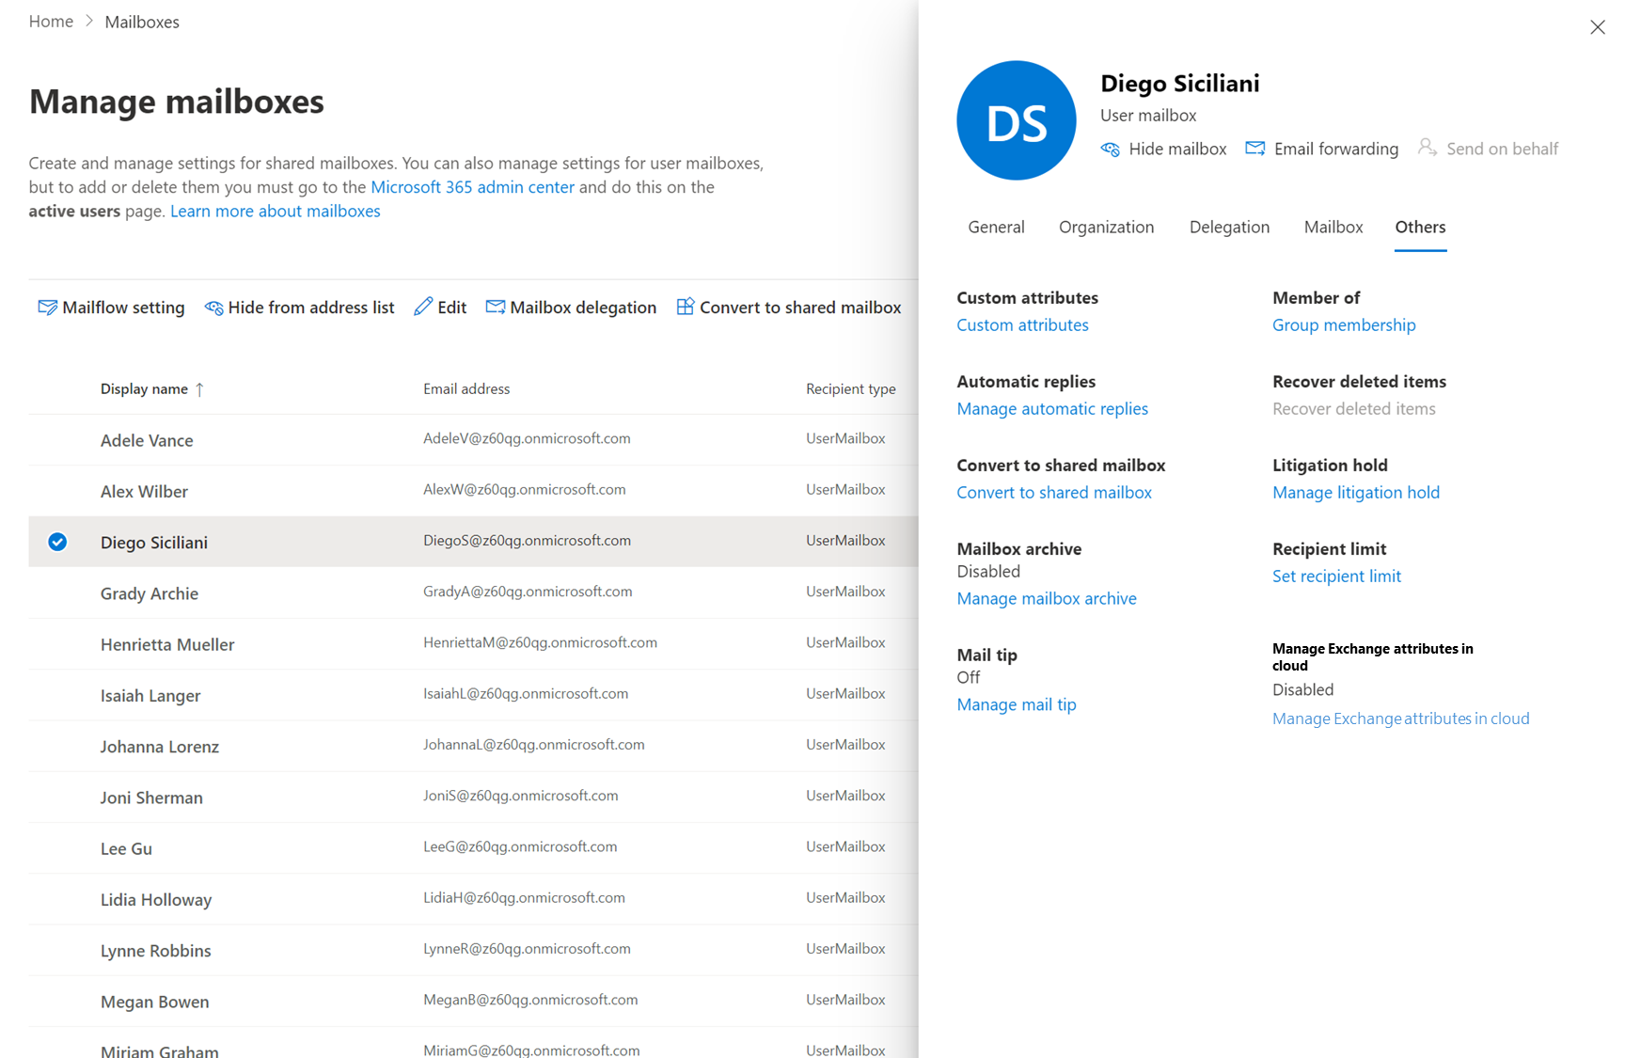

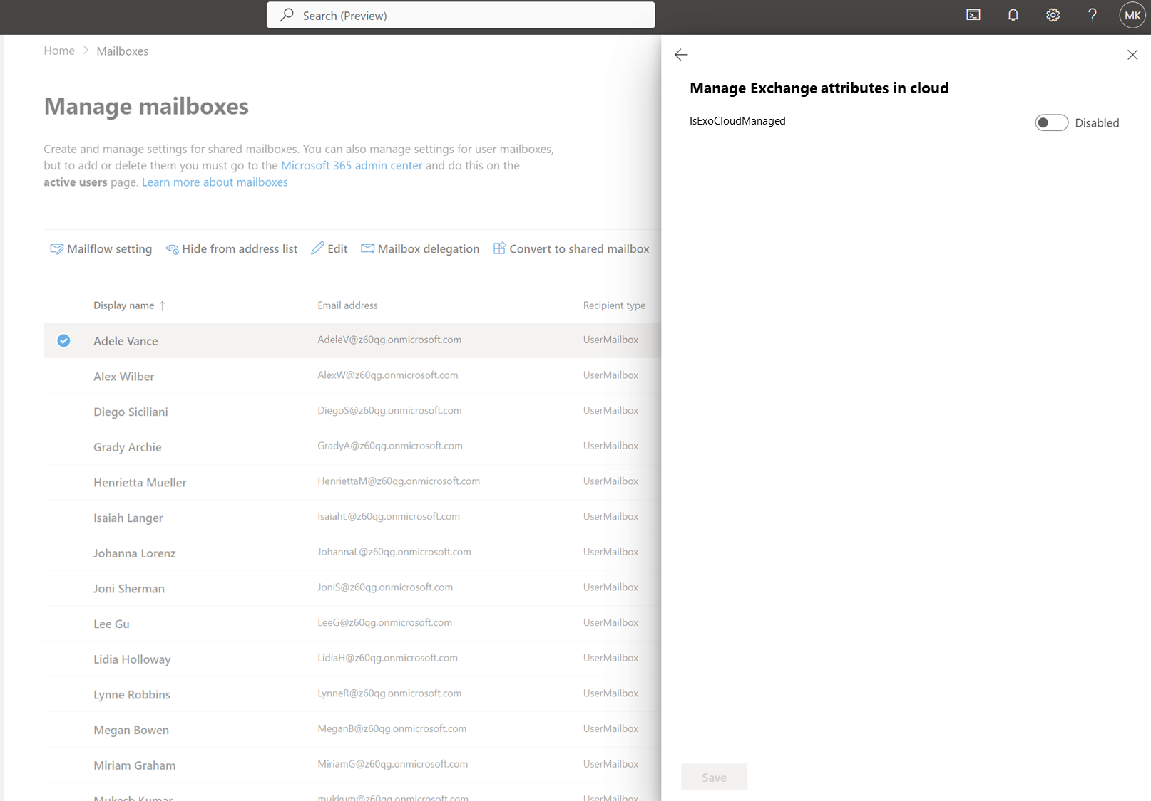

Manage exchange attributes of cloud mailboxes in EXO after setting IsExchangeCloudManaged to True
- Determine all the cloud mailboxes whose exchange attributes can be managed in cloud
To find out mailboxes that can now be managed in cloud, admin can run the following command.
Get-Mailbox
-Filter "(IsExchangeCloudManaged -eq 'True')”

Output:
CU1
CU2
CU3

In EAC, we need to add isExchangeCloudmanaged to Column chooser.
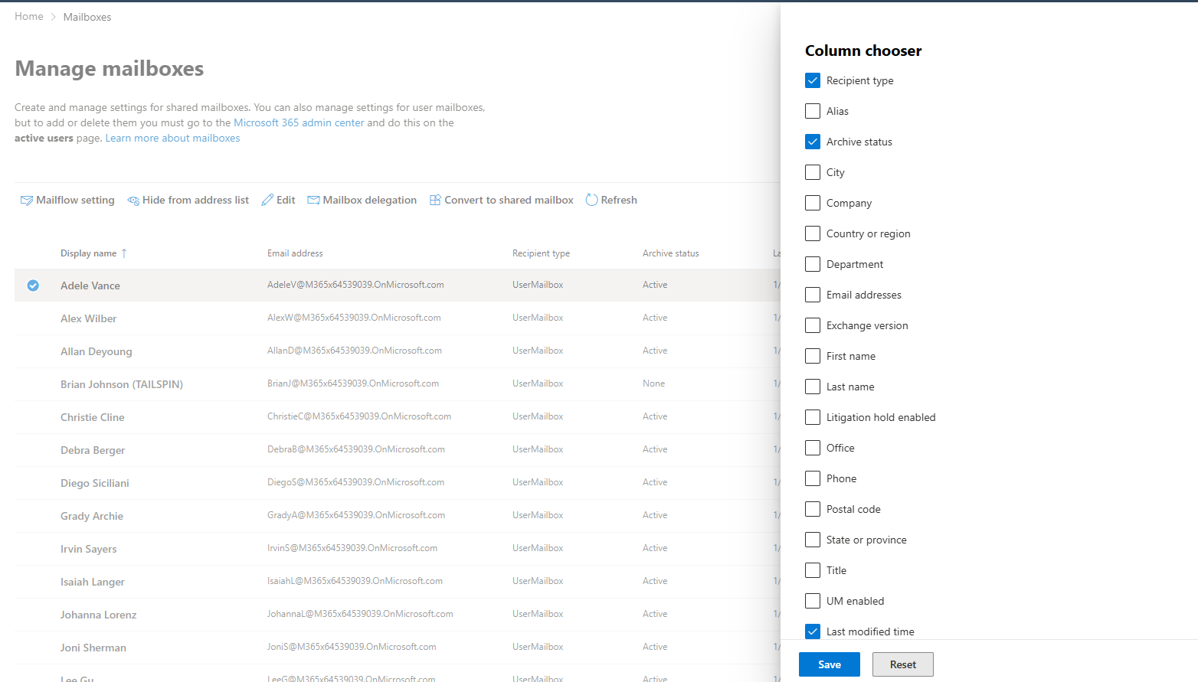

- Edit/Manage exchange attributes of these mailboxes in cloud
- Admins must use set-mailbox command to manage/edit exchange attributes directly in cloud.
Set-Mailbox
-Identity CU1
-customattribute1 "Test"

- Admins should ensure that they only edit exchange attributes through this cmdlet, or else the cmdlet will error out without making any change. For example, if displayname (not editable in cloud) is attempted to change along with customattributes (editable in cloud), the cmdlet will give an error:
Set-Mailbox
-Identity CU1
-customattribute1 "Test2"
-displayname “User2”
Error: Set-Mailbox cannot modify Identity attribute as only the Exchange attributes are editable for this user. None of the parameters were changed. Learn more: https://aka.ms/ExchangeCloudManaged
- If admin tries to edit, an user whose isExchangecloudmanaged property is False, they will see following error.
Set-Mailbox
-Identity NonEditableUser
-customattribute1 "Test"
Set-Mailbox: |Microsoft.Exchange.Configuration.DualWrite.LocStrings.UnableToWriteToAadException|An Azure Active Directory call was made to keep object in sync between Azure Active Directory and Exchange Online. However, it failed. Detailed error message: Unable to update the specified properties for on-premises mastered Directory Sync objects or objects currently undergoing migration. DualWrite (Graph) RequestId: 8598bbde-d2ec-4726-b1c3-8b516ee1037b The issue may be transient and please retry a couple of minutes later. If issue persists, please see exception members for more information.
No change in EAC, because EAC already shows the status.

Stop using Exchange Server for managing cloud mailboxes.
As we are not blocking changes in AD/Exchange for Exchange attributes of cloud managed user mailboxes. Admins will need to ensure that they don’t edit exchange attributes directly in AD/Exchange. We will need to communicate this to customers via blog.
Customers should also be able to track type of sync (Account + Exchange or only Account) by checking AAD connect/cloud sync logs.

New user/mailbox creation when Exchange attributes are editable in cloud
Since customers are looking to remove their last exchange servers. Henceforth, need not create new remote mailbox in Exchange Server for mailbox creation. They can create new cloud mailboxes from on-premises AD by following steps and then make their Exchange attributes editable in cloud.
- Create a new remote mailbox via Exchange Management tools or
Or, create a new user directly in on-premises AD, and after the user is synchronized to EntraID, assign the user a valid license to provision mailbox for the user in cloud.
- Set IsExchangeCloudManaged = True for the user in cloud to start managing their exchange attributes in cloud.
Fully cloud users who have isDirsync = False, can still be directly created in cloud. As they are not impacted by the change.

User Deletion.
All the dirsynced exchange recipients whose exchange attributes are editable, can still be deleted or account disabled from onprem AD. AAD Connect and AAD cloud sync will ensure deletion/disablement is replicated in EntraID after the activity is done in onpremises AD.

Rollback scenario or making EXO editable dirsynced recipients non-editable again.
Exchange admins can choose to go back to previous state for a user, essentially making their exchange attributes non-editable in cloud:
- All the mailboxes which must revert to previous state, admins should set IsExchangeCloudManaged back to False, by using following command.

Set-Mailbox
-Identity CU1
-IsExchangeCloudManaged False

- In next sync cycle for all the above mailboxes whose IsExchangeCloudManaged is set to FALSE, the AAD Connect or AAD cloud Sync will go back to previous state and start syncing onprem values of attributes to AAD/EXO AD. Exchange will not allow attribute management in cloud.
Note: All the exchange attributes, which are not part of Writeback scope, the stale values of onprem AD will be overwritten to AAD/EXOAD. Admins need to be okay with this, before opting for this feature. This will be communicated to customers via blog only.

Transition period where Both Exchange Hybrid and LES would coexist for the same tenant.
Till customers haven’t enabled IsExchangeCloudManaged for the entire mailboxes of the tenant. A tenant can have some object in pure Exchange Hybrid state where both account and exchange attributes are synced from onprem to cloud and some in new-Hybrid state where only exchange attributes are editable in cloud.
As mentioned above, customers can use EAC or following cmdlet in Exchange Powershell to determine
Get-Mailbox
-IncludeCloudManaged
-Filter "(IsExchangeCloudManaged -eq 'True')”
As object SOA will be enabled before the Exchange attribute SOA transfer, customers can have some erstwhile dirsynced mailboxes which are now fully editable in cloud (account and exchange attribute both). Customers can view all the mailboxes fully editable in cloud after object SOA transfer, but the list will include all the mailboxes that were created directly in cloud too.
Get-recipient -Filter "(IsDirSynced -eq 'False') -and (RecipientType -eq 'UserMailbox')"

Day N experience
This signifies a point in time, where admins are fairly satisfied with the cloud management of Exchange attributes of dirsynced user mailboxes. Now along with above capabilities, admins will look for following new capabilities:
- Convert all remaining dirsynced onpremises AD managed mailboxes to cloud managed
- Ensure all new dirsynced mailboxes are cloud managed by default.
- New User creation

Convert remaining dirsynced onpremises AD managed mailboxes to cloud managed
Admins can easily convert all their non-cloud managed dirsynced mailboxes to cloud managed by executing following cmdlet:
Get-Mailbox
-IncludeCloudManaged
-Filter "(IsExchangeCloudManaged -eq 'False') -and (IsDirSynced -eq 'True')"
| Set-Mailbox -IsExchangeCloudManaged True

Ensure all new dirsynced mailboxes are cloud managed by default
Admins must be able to ensure default of value of IsExchangeCloudManaged is True for new dirsynced mailboxes, to ensure smoother transition to cloud managed mailboxes and removal of Last Exchange Server.
Admins can do this by using following cmdlet:
Set-OrganizationConfig -ExchangeAttributesCloudManagedbyDefault True
The above cmdlet only affects new mailboxes created. Whenever the value of ExchangeAttributesCloudManagedbyDefault is set to False, new mailboxes hence created will again have isExchangeCloudManaged set to False.
Note: To force cutover, rollback of ExchangeAttributesCloudManagedbyDefault will be disabled for admins.

New user/mailbox creation after isExchangeCloudManaged is True by default
Since at tenant level, any new dirsynced mailbox will have Exchangeattribute editable in cloud by default. Creating new users in onpremises AD and assigning cloud mailboxes for these users will become a much easier task. Steps involved in this activity are:
- Create a new user directly in onprem AD. (EntraID will block the sync of user’s exchange attributes, exchange cmdlet is used for creation of user).
- If a new user was created directly in AD, once the user is synchronized to EntraID, assign the user a valid license to provision mailbox for the user in cloud.

Forced Cutover [Not planned in initial scope]
Once a customer starts using Recipient management at user level or tenant level, we must give customers a timed period during which Exchange Hybrid and Recipient management via cloud would co-exist. This timeframe could be 6-8 months from the day they start using this feature. This is to ensure customers don’t remain in this dual state of Exchange Hybrid and cloud management recipients forever.
After the expiry of this transition period, to force customers get rid of exchange server, we can force Exchange Hybrid SHUTDOWN for customers who have their mailboxes managed in cloud. This Hybrid feature shutdown can include breaking of following features.
- Disable Offboarding of mailboxes to Server.
- Disable Oauth configured between EXO and Exchange Server making features like cross-premise F/B, mail-tips won’t work.
- Disable Inbound Connectors to not allow easy secure mail transfer from Exchange server mailboxes to cloud.

Exchange Recipients and the attributes in scope for attribute level SOA transfer
Here is the list of AD attributes (both account and exchange) that are today getting synced from on-premises AD to Entra ID.
In the table below, Attribute needing SOA transfer column specifies all the attributes for which SOA should be transferred to cloud and these are specified by a green cell with the value “Yes”, whereas all the attributes that are marked No, SOA should remain in on-premises AD.
Note: Avinash confirmed that all the attributes in scope are only editable in ExO and not in AAD.
Attribute Name | Is Link | Attribute needing SOA transfer | User | Group | Contacts | Dual write to AAD | LES writeback attributes | In scope for Object SOA writeback? (UPAD/GPAD)
accountEnabled |  | No | X |  |  | No |  | X
altRecipient | Yes | Yes | X |  |  | No
authorig | Yes | Yes | X | X | X | No
C |  | No | X |  | X | No
Cn |  | No | X | X |  | No
Co |  | No | X |  | X | No |  | X
company |  | No | X |  | X | No |  | X
countryCode |  | No | X |  | X | Yes
department |  | No | X |  | X | Yes |  | X
description |  | No |  | X |  | Yes |  | X
displayName |  | No | X | X | X | Yes |  | X
dLMemRejectPerms | Yes | Yes | X | X | X | No
dLMemSubmitPerms | Yes | Yes | X | X | X | No
extensionAttribute1 |  | Yes | X | X | X | Yes | X | x
extensionAttribute2 |  | Yes | X | X | X | Yes | X | x
extensionAttribute3 |  | Yes | X | X | X | Yes | X | x
extensionAttribute4 |  | Yes | X | X | X | Yes | X | x
extensionAttribute5 |  | Yes | X | X | X | Yes | X | x
extensionAttribute6 |  | Yes | X | X | X | Yes | X | x
extensionAttribute7 |  | Yes | X | X | X | Yes | X | x
extensionAttribute8 |  | Yes | X | X | X | Yes | X | x
extensionAttribute9 |  | Yes | X | X | X | Yes | X | x
extensionAttribute10 |  | Yes | X | X | X | Yes | X | x
extensionAttribute11 |  | Yes | X | X | X | Yes | X | x
extensionAttribute12 |  | Yes | X | X | X | Yes | X | x
extensionAttribute13 |  | Yes | X | X | X | Yes | X | X
extensionAttribute14 |  | Yes | X | X | X | Yes | X | x
extensionAttribute15 |  | Yes | X | X | X | Yes | X | x
facsimiletelephonenumber |  | No | X |  | X | Yes |  | X
givenName |  | No | X |  | X | Yes |  | X
homePhone |  | No | X |  | X | Yes
info |  | No | X | X | X | Yes
Initials |  | No | X |  | X | Yes
L |  | No | X |  | X | No
legacyExchangeDN |  | Yes | X | X | X | No
mailNickname |  | No | X | X | X | Yes |  | x
managedBy |  | Yes |  | X |  | Yes
manager |  | No | X |  | X | Yes |  | x
member |  | Yes |  | X |  | No |  | X
mobile |  | No | X |  | X | Yes |  | x
msDS-HABSeniorityIndex |  | No | X | X | X | No
msDS-PhoneticDisplayName |  | No | X | X | X | No
msExchArchiveGUID |  | Yes | X |  |  | No
msExchArchiveName |  | Yes | X |  |  | No
msExchAssistantName |  | Yes | X |  | X | Yes
msExchAuditAdmin |  | Yes | X |  |  | No
msExchAuditDelegate |  | Yes | X |  |  | No
msExchAuditDelegateAdmin |  | Yes | X |  |  | No
msExchAuditOwner |  | Yes | X |  |  | No
msExchBlockedSendersHash |  | Yes | X |  | X | No
msExchBypassAudit |  | Yes | X |  |  | No
msExchBypassModerationLink | Yes | Yes |  | X |  | No
msExchCoManagedByLink | Yes | Yes |  | X |  | No
msExchDelegateListLink | Yes | Yes | X |  |  | No
msExchELCExpirySuspensionEnd |  | Yes | X |  |  | No
msExchELCExpirySuspensionStart |  | Yes | X |  |  | No
msExchELCMailboxFlags |  | Yes | X |  |  | No
msExchEnableModeration |  | Yes | X | X |  | No
msExchExtensionCustomAttribute1 |  | Yes | X | X | X | No | X
msExchExtensionCustomAttribute2 |  | Yes | X | X | X | No | X
msExchExtensionCustomAttribute3 |  | Yes | X | X | X | No | X
msExchExtensionCustomAttribute4 |  | Yes | X | X | X | No | X
msExchExtensionCustomAttribute5 |  | Yes | X | X | X | No | X
msExchHideFromAddressLists |  | Yes | X | X | X | No
msExchImmutableID |  | Yes | X |  |  | No
msExchLitigationHoldDate |  | Yes | X | X | X | No
msExchLitigationHoldOwner |  | Yes | X | X | X | No
msExchMailboxAuditEnable |  | Yes | X |  |  | No
msExchMailboxAuditLogAgeLimit |  | Yes | X |  |  | No
msExchMailboxGuid |  | Yes | X |  |  | No
msExchModeratedByLink | Yes | Yes | X | X | X | No
msExchModerationFlags |  | Yes | X | X | X | No
msExchRecipientDisplayType |  | Yes | X | X | X | No | X
msExchRecipientTypeDetails |  | Yes | X | X | X | No | X
msExchRemoteRecipientType |  | Yes | X |  |  | No
msExchRequireAuthToSendTo |  | Yes | X | X | X | No
msExchResourceCapacity |  | Yes | X |  |  | No
msExchResourceDisplay |  | Yes | X |  |  | No
msExchResourceMetaData |  | Yes | X |  |  | No
msExchResourceSearchProperties |  | Yes | X |  |  | No
msExchRetentionComment |  | Yes | X | X | X | No
msExchRetentionURL |  | Yes | X | X | X | No
msExchSafeRecipientsHash |  | Yes | X |  | X | No
msExchSafeSendersHash |  | Yes | X |  | X | No
msExchSenderHintTranslations |  | Yes | X | X | X | No
msExchTeamMailboxExpiration |  | Yes | X |  |  | No
msExchTeamMailboxOwners |  | Yes | X |  |  | No
msExchTeamMailboxSharePointUrl |  | Yes | X |  |  | No
msExchUserHoldPolicies |  | Yes | X |  |  | No
msOrg-IsOrganizational |  | No |  | X |  | No
objectSID |  | No | X | X |  | No
oOFReplyToOriginator |  | Yes |  | X |  | No
otherFacsimileTelephone |  | No | X |  | X | No
otherHomePhone |  | No | X |  | X | Yes
otherTelephone |  | No | X |  | X | Yes
pager |  | No | X |  | X | Yes
physicalDeliveryOfficeName |  | No | X |  | X | Yes
postalCode |  | No | X |  | X | Yes |  | x
proxyAddresses |  | Yes | X | X | X | Yes | X | x
publicDelegates | Yes | Yes | X | X | X | No
pwdLastSet |  | No | X |  |  | No
reportToOriginator |  | Yes |  | X |  | No
reportToOwner |  | Yes |  | X |  | No
securityEnabled |  | Yes |  | X |  | Yes
sn |  | No | X |  | X | No
sourceAnchor |  | No | X | X | X | No
st |  | No | X |  | X | No
streetAddress |  | No | X |  | X | Yes |  | x
targetAddress |  | Yes | X |  | X | Yes
telephoneAssistant |  | No | X |  | X | Yes
telephoneNumber |  | No | X |  | X | Yes
thumbnailphoto |  | Yes | X |  | X | No
title |  | No | X |  | X | No
unauthOrig | Yes | Yes | X | X | X | No
usageLocation |  | No | X |  |  | No
userCertificate |  | Yes | X |  | X | No
userPrincipalName |  | No | X |  |  | No
userSMIMECertificates |  | Yes | X |  | X | No
wWWHomePage |  | No | X |  | X | No

Telemetry
To measure success of this feature, we need to track the following:
- How many customers have tried this feature? This will tell us which customers are aware of this solution and have started using it. This can be tracked by:
- Number of Tenants who have enabled this feature (i.e isEXOcloudmanaged = True for any number of mailbox).
- Additionally percentage of dirsynced mailboxes for which this flag is TRUE will help us understand how many customers have moved from trial phase to production phase where they are using EXO to manage dirsynced mailboxes.
- How many customers removed their Exchange Servers and shutdown their Exchange Hybrid configuration?
- We need to measure number of servers removed by customers who have enabled this feature. This can be tracked by using transport telemetry to identify number of exchange servers from the tenants identified in step 1.
- We can also track number of customers who have removed hybrid configuration like inbound connector, oauth configuration etc.
- Additionally, number of customers who have enabled tenant level flag will tell us about customers who have organically removed the use of Exchange Server recipient management.

Other considerations

Ensure ongoing mailbox migration doesn’t interfere or gets interrupted by allowing exchange attributes edit in cloud
To ensure ongoing mailbox migration especially offboarding is not affected by LES Recipient Management, we can have following checks:
- Admins must not set IsExchangeCloudManaged = True for the mailbox which is currently being migrated.
Proposal: A script can be given to admins to identify mailboxes currently being migrated via MoveRequest or MigrationBatch.

- Not allow mailboxes with IsExchangeCloudManaged = True, to get migrated to Exchange Server.
Proposal: A script can be given to admins to identify mailboxes are currently being manged in EXO, so that they don’t initiate Offboarding for these mailboxes.

Delegate mailbox scenario and its implications.
Need to add issues if there are due to delegate scenario.

